Declaration of own work

I, Nguyễn Trung Tâm (B1910697) , certify that this assignment is my own work, is not copied from

any other person's work.

# Part 1)

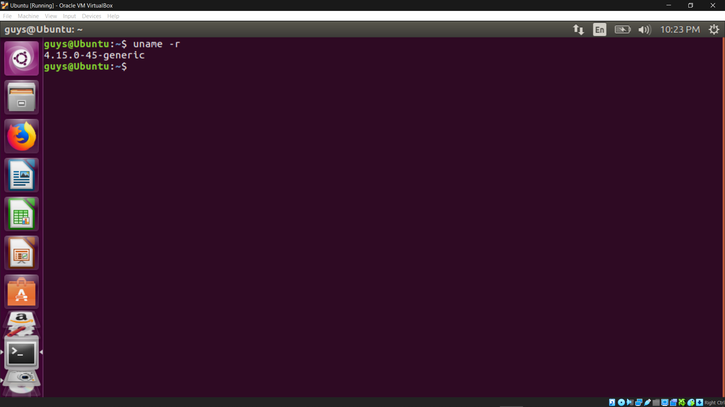

apt-get install gcc

apt-get install libncurses5-dev

apt-get install bison

apt-get install flex

apt-get install libssl-dev

apt-get install libelf-dev

apt-get update

apt-get upgrade

wget <https://www.kernel.org/pub/linux/kernel/v4.x/linux-4.17.4.tar.xz>

tar -xvf linux-4.17.4.tar.xz -C/usr/src/

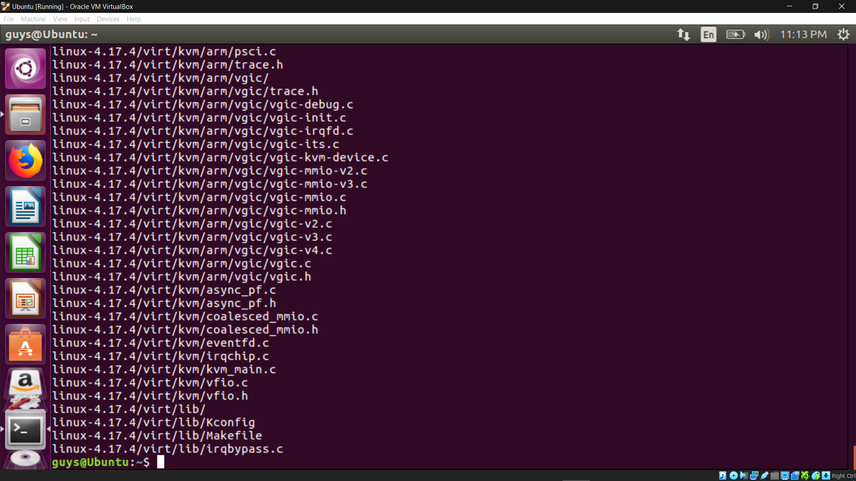

make menuconfig

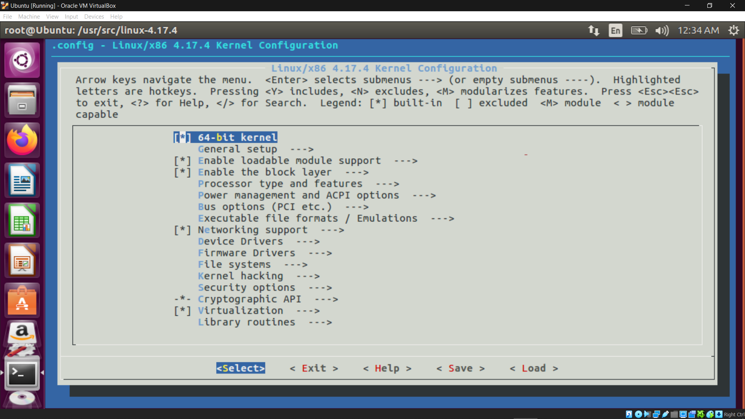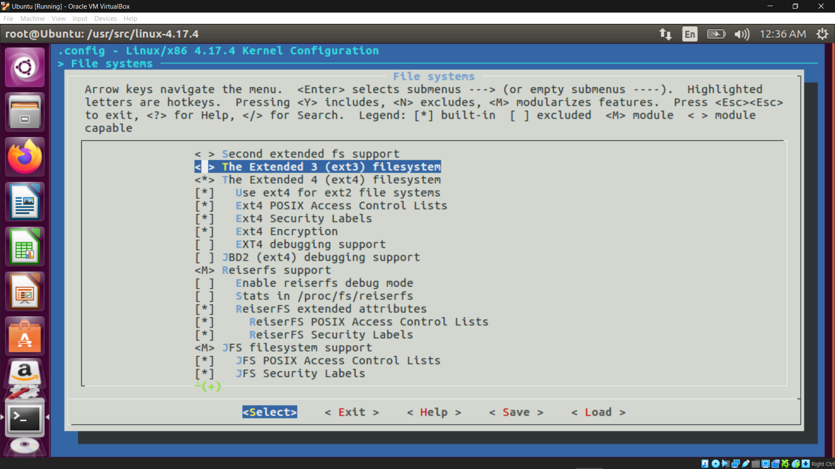

make

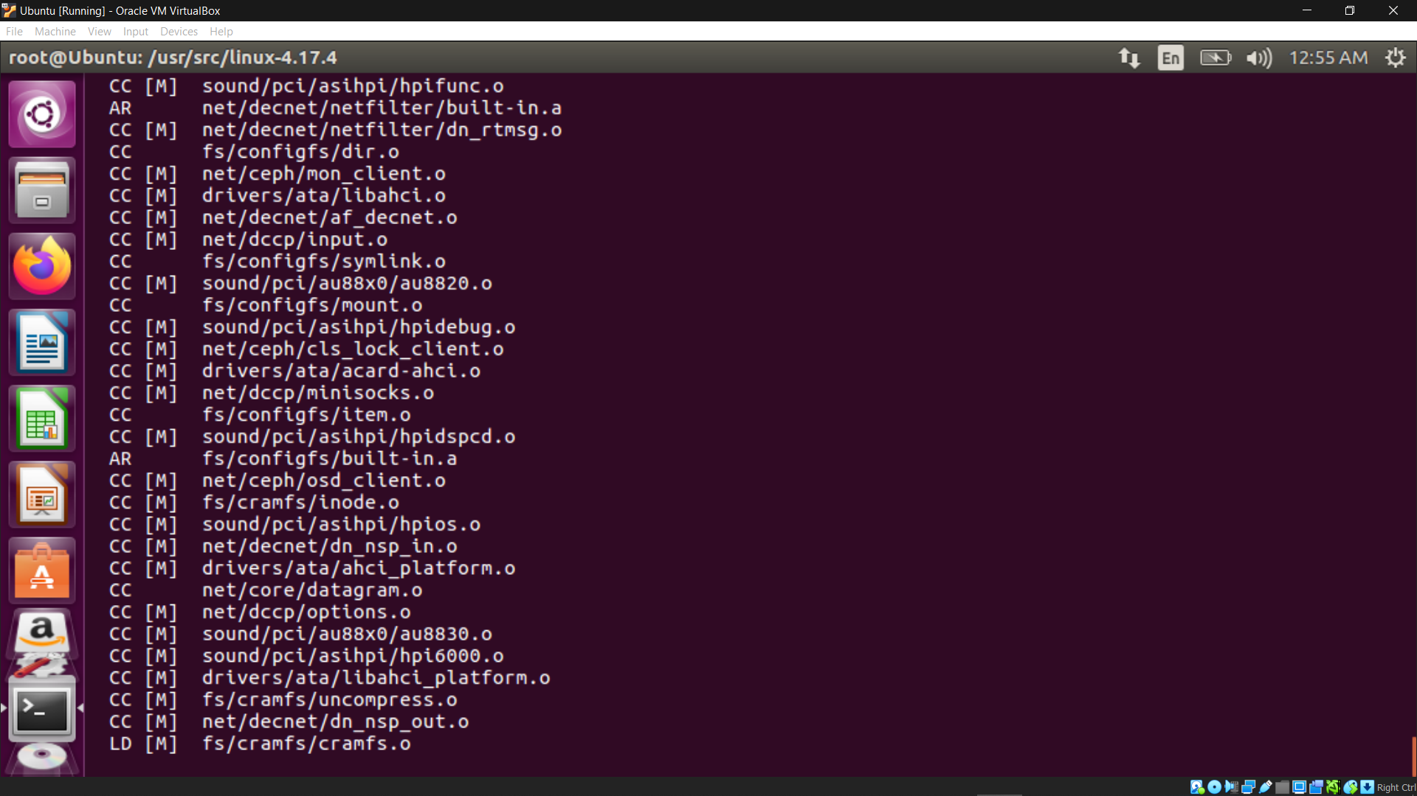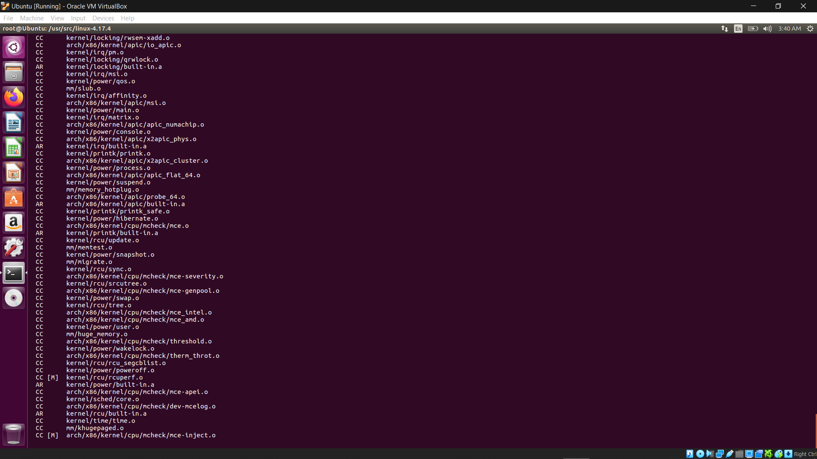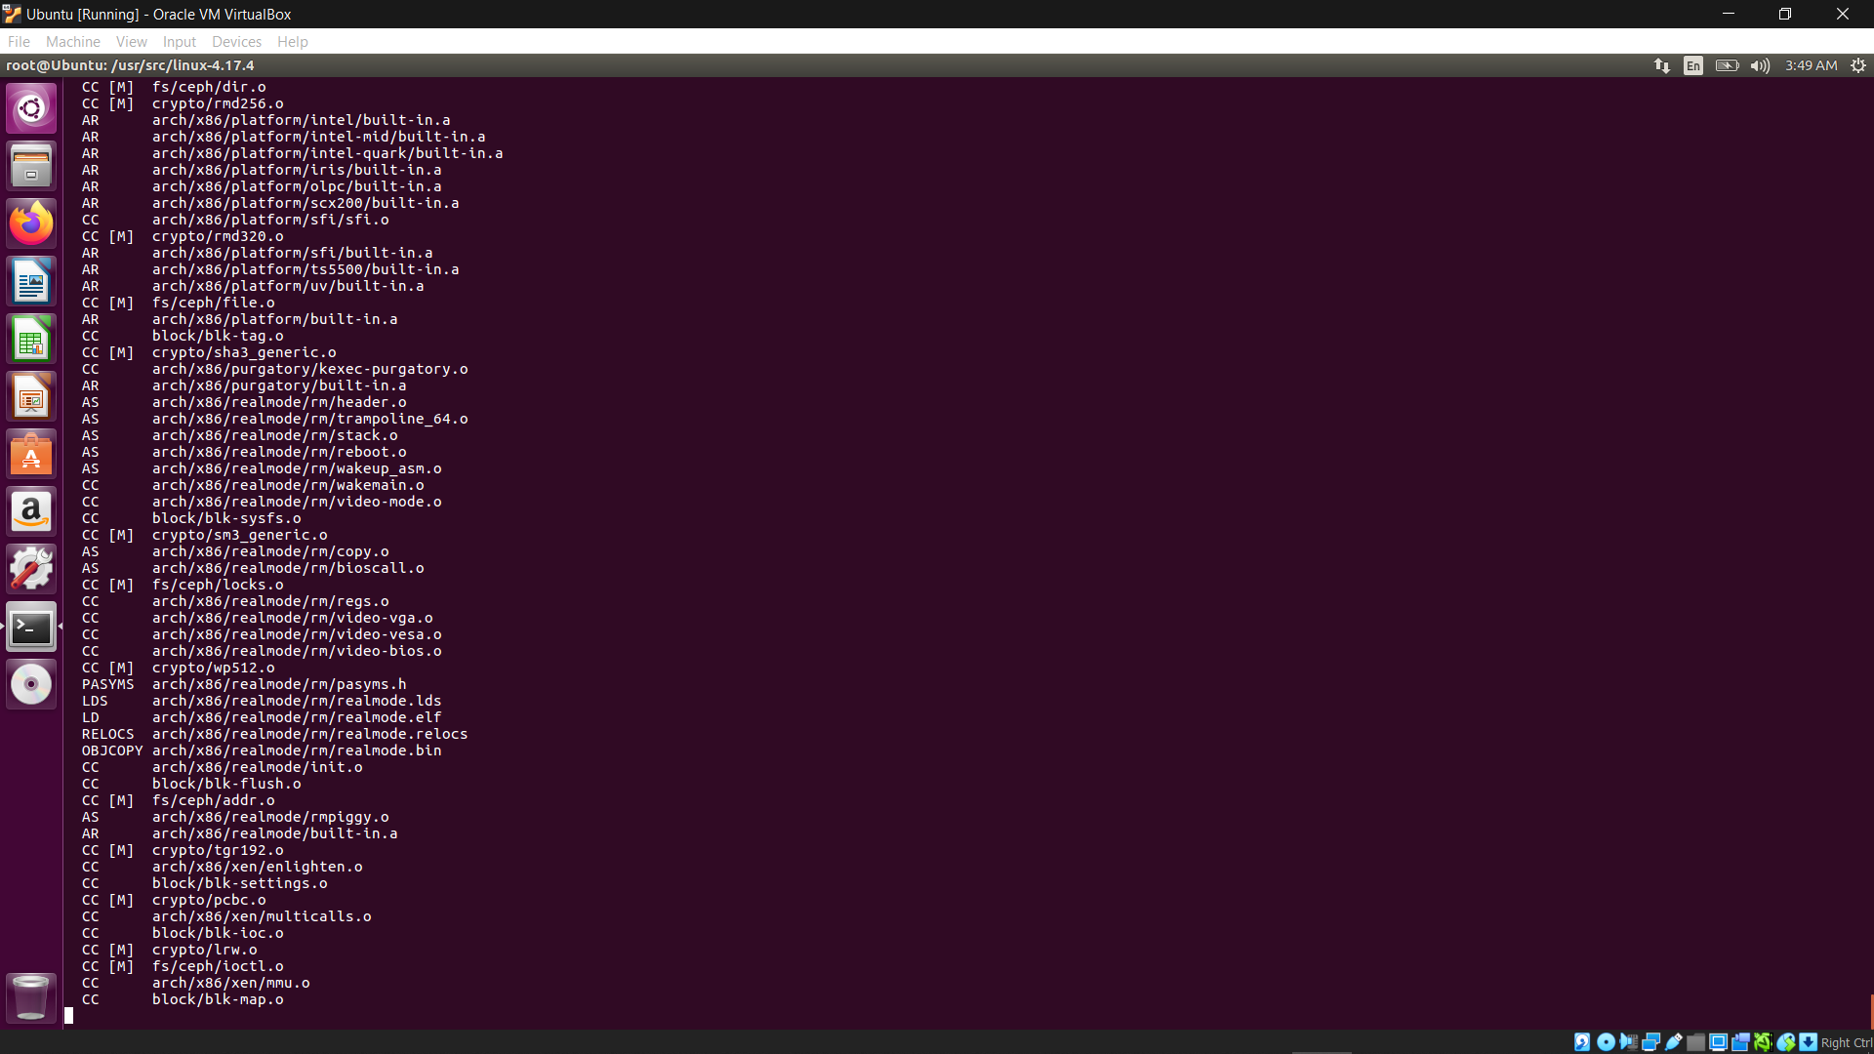

make modules_install install

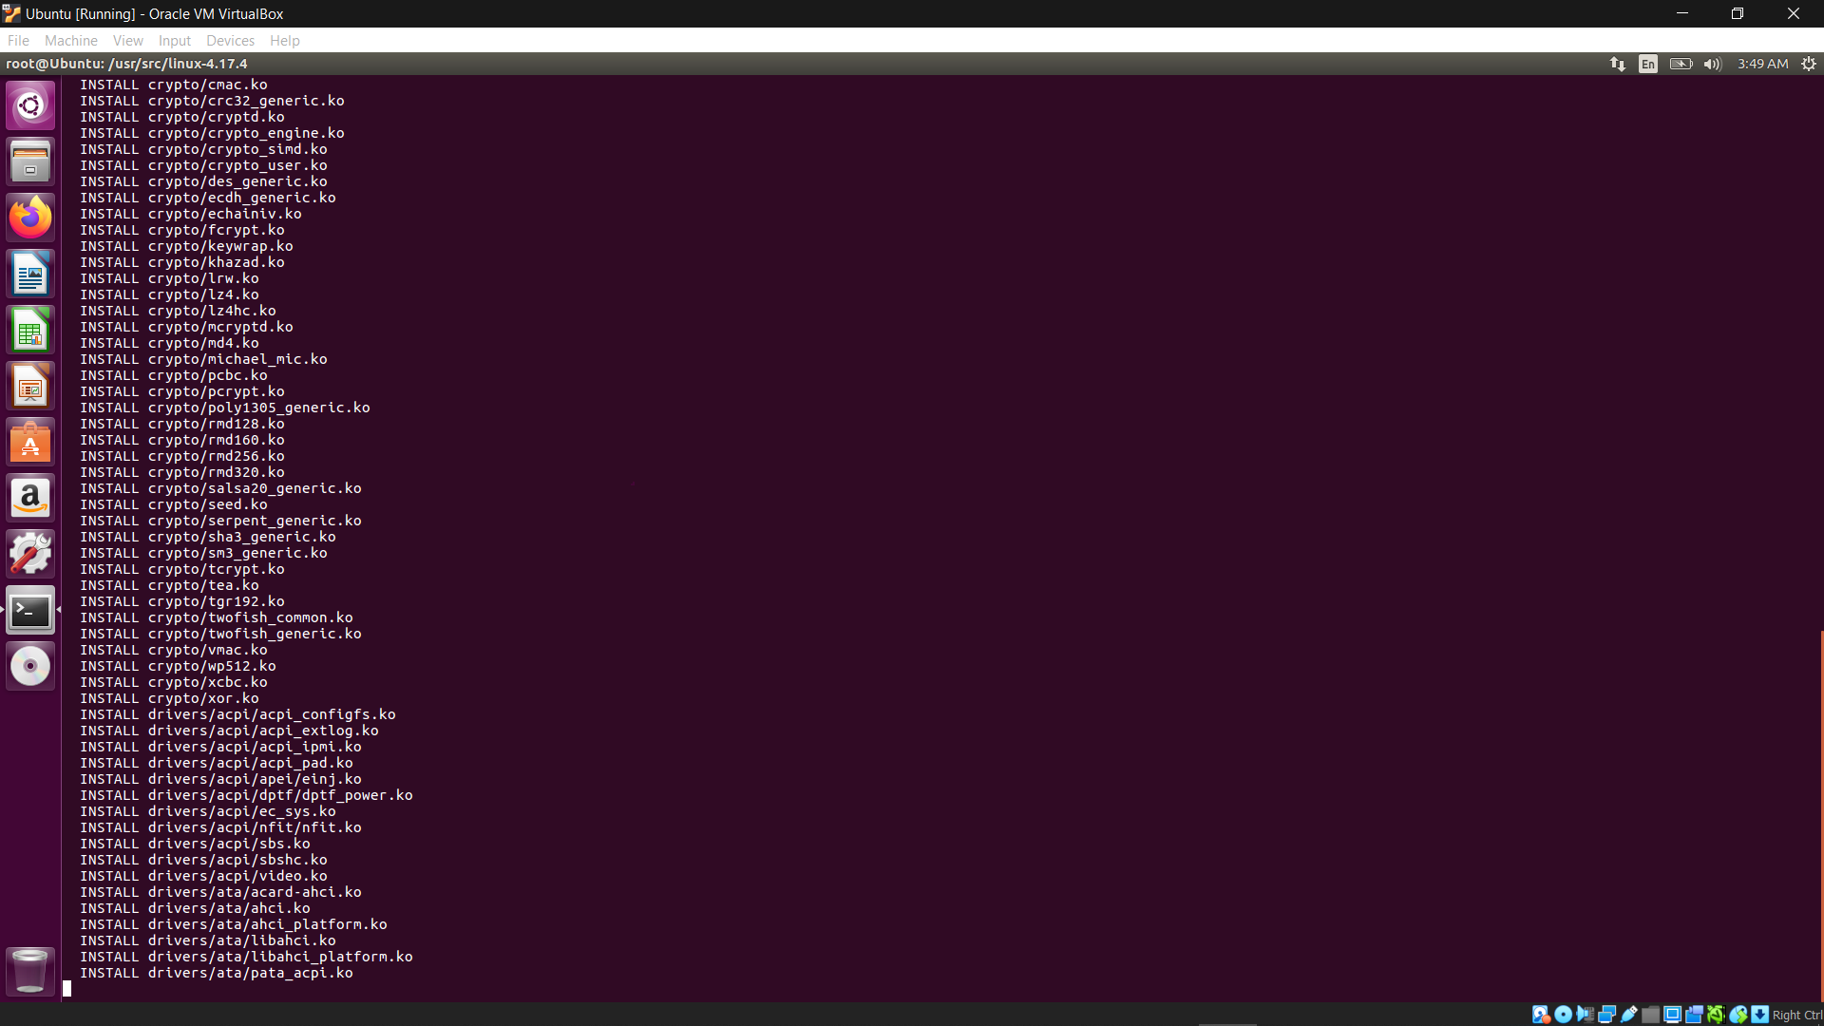

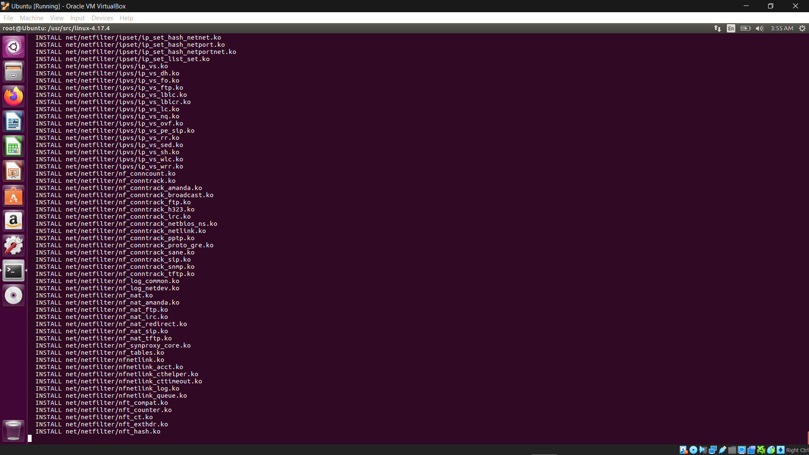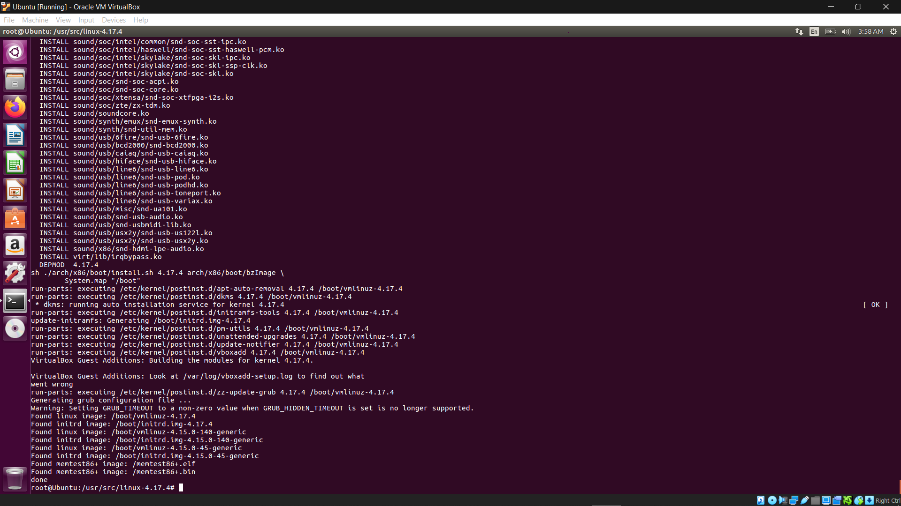

uname -r

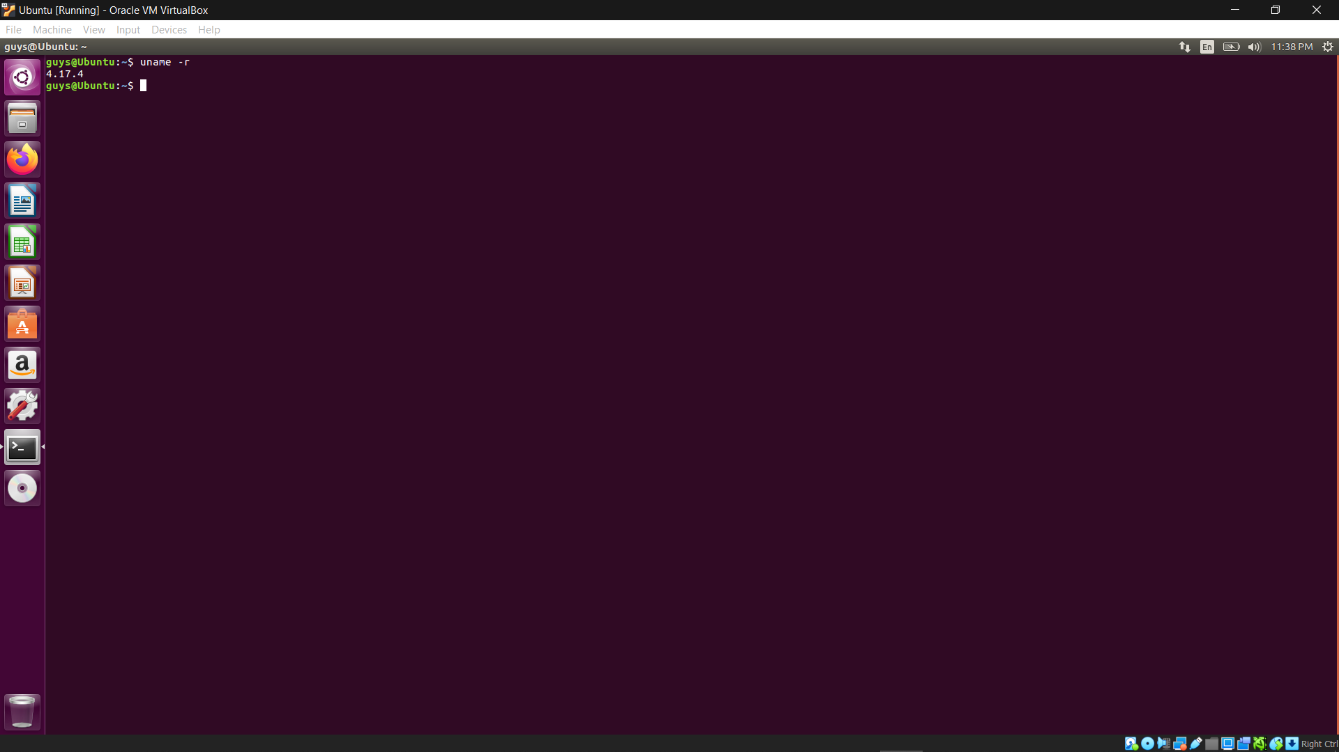

Part 2)

wget <https://www.kernel.org/pub/linux/kernel/v4.x/linux-4.17.4.tar.xz>

tar -xvf linux-4.17.4.tar.xz -C/usr/src/



uname -r



mkdir hello

cd hello

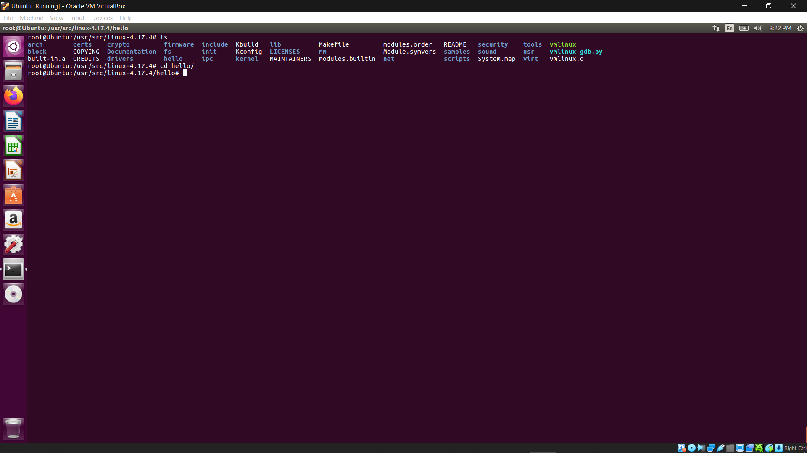

vi helloworld.c

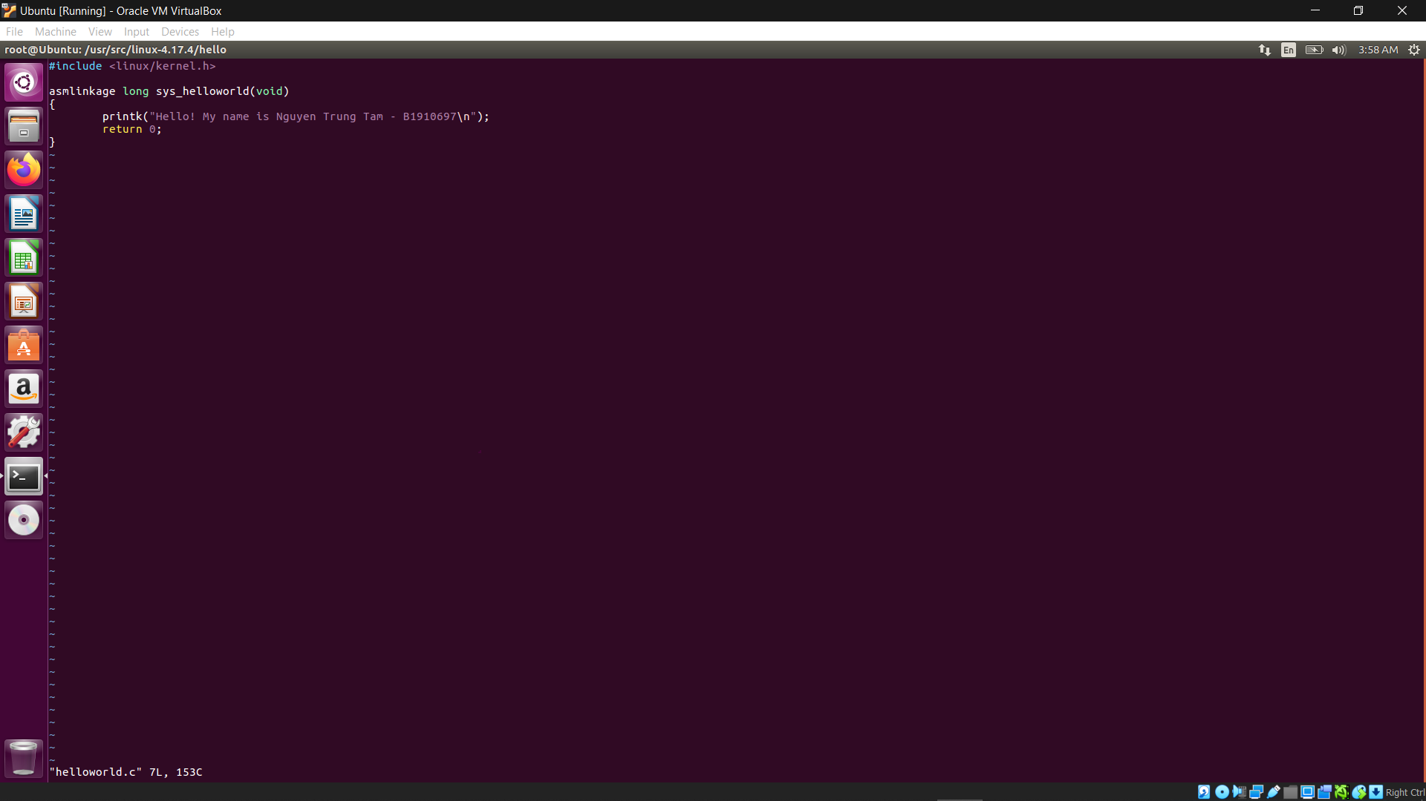

vi Makefile

obj := helloworld.o

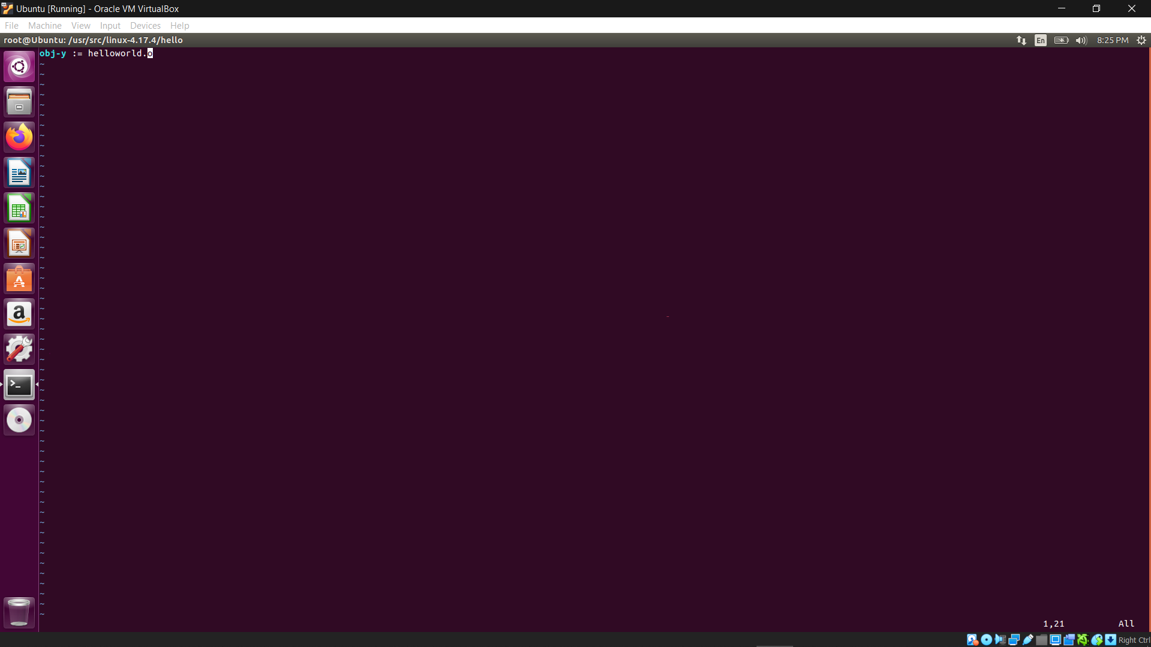

cd ..

vi Makefile

core-y += kernel/ mm/ fs/ ipc/ security/ crypto/ block/ hello/

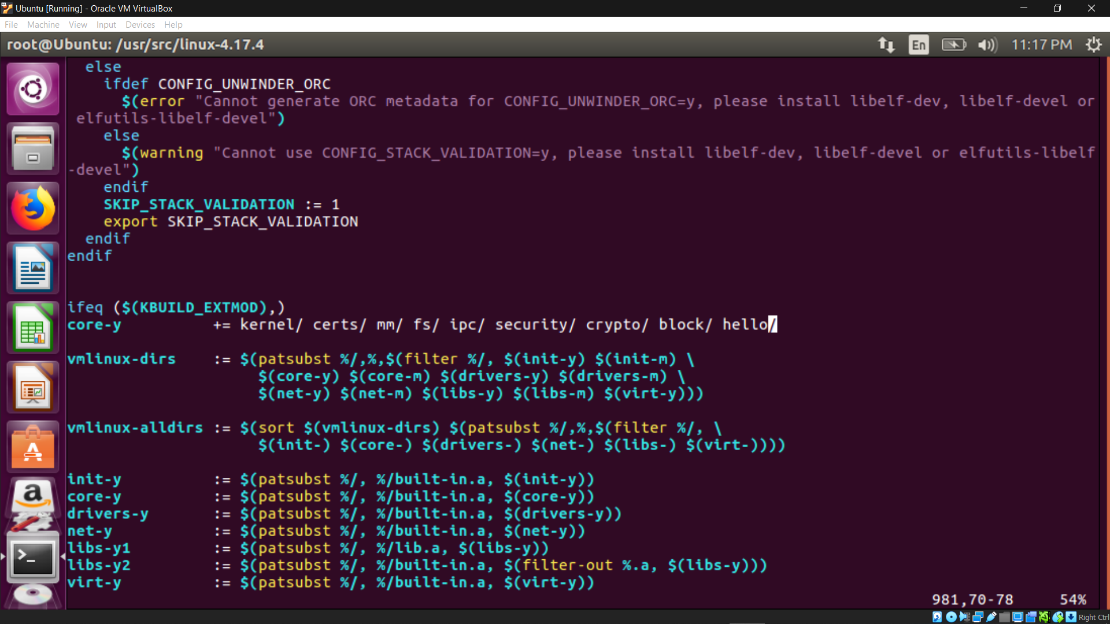

cd arch/x86/entry/syscalls/

vi syscall_64.tbl

548 64 helloworld sys_helloworld

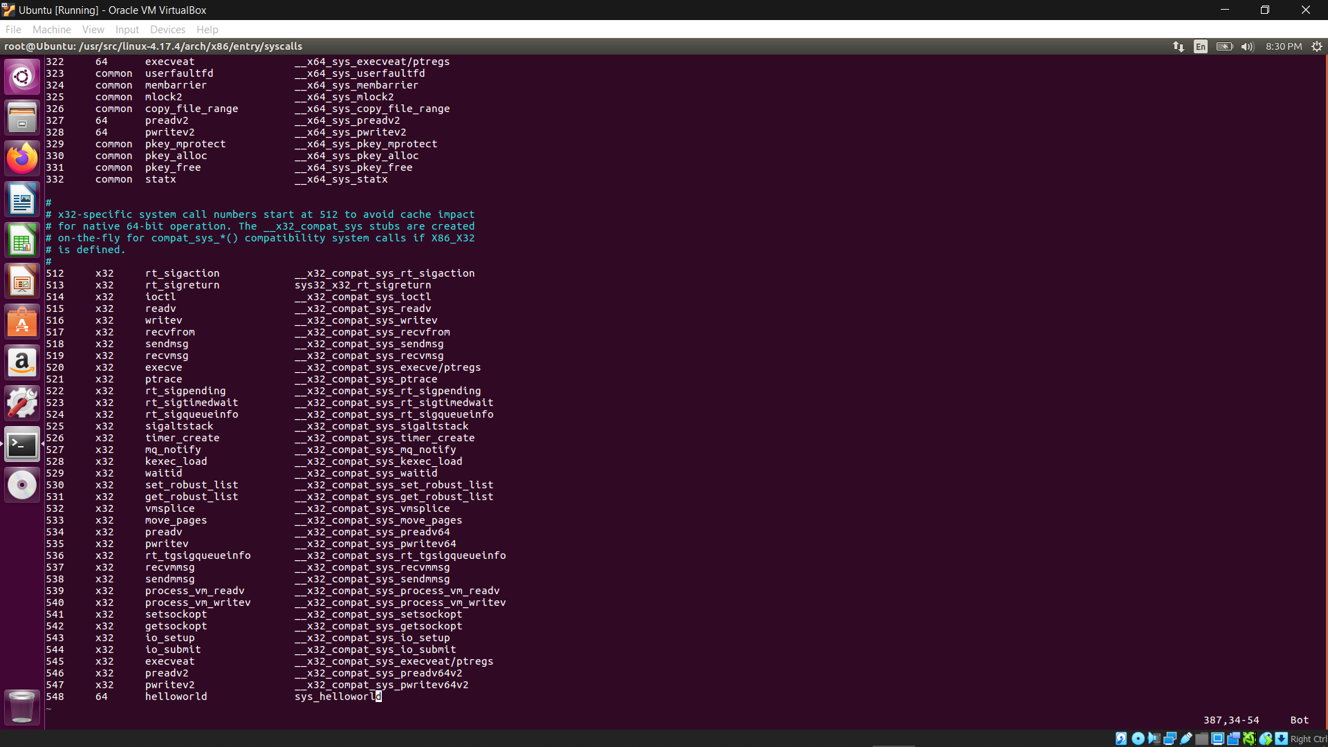

cd include/linux/

vi syscalls.h

asmlinkage long sys_helloworld(void);

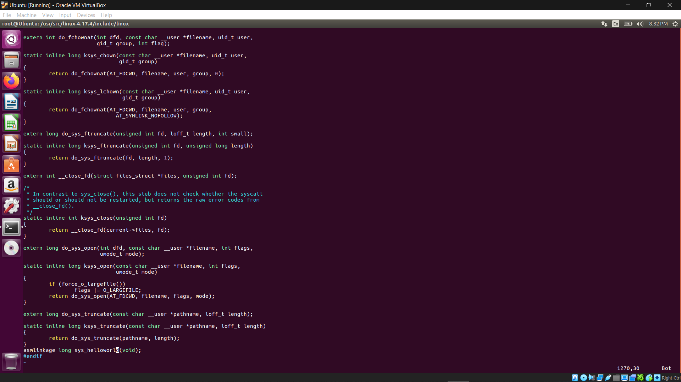

apt-get install gcc

apt-get install libncurses5-dev

apt-get install bison

apt-get install flex

apt-get install libssl-dev

apt-get install libelf-dev

apt-get update

apt-get upgrade

make menuconfig



make



make modules_install install





uname -r



cd ~

vi test.c

#include <stdio.h>

#include <linux/kernel.h>

#include <sys/syscall.h>

#include <unistd.h>

int main()

{

long int amma = syscall(548);

printf("System call sys_hello returned %ld\n", amma);

return 0;

}

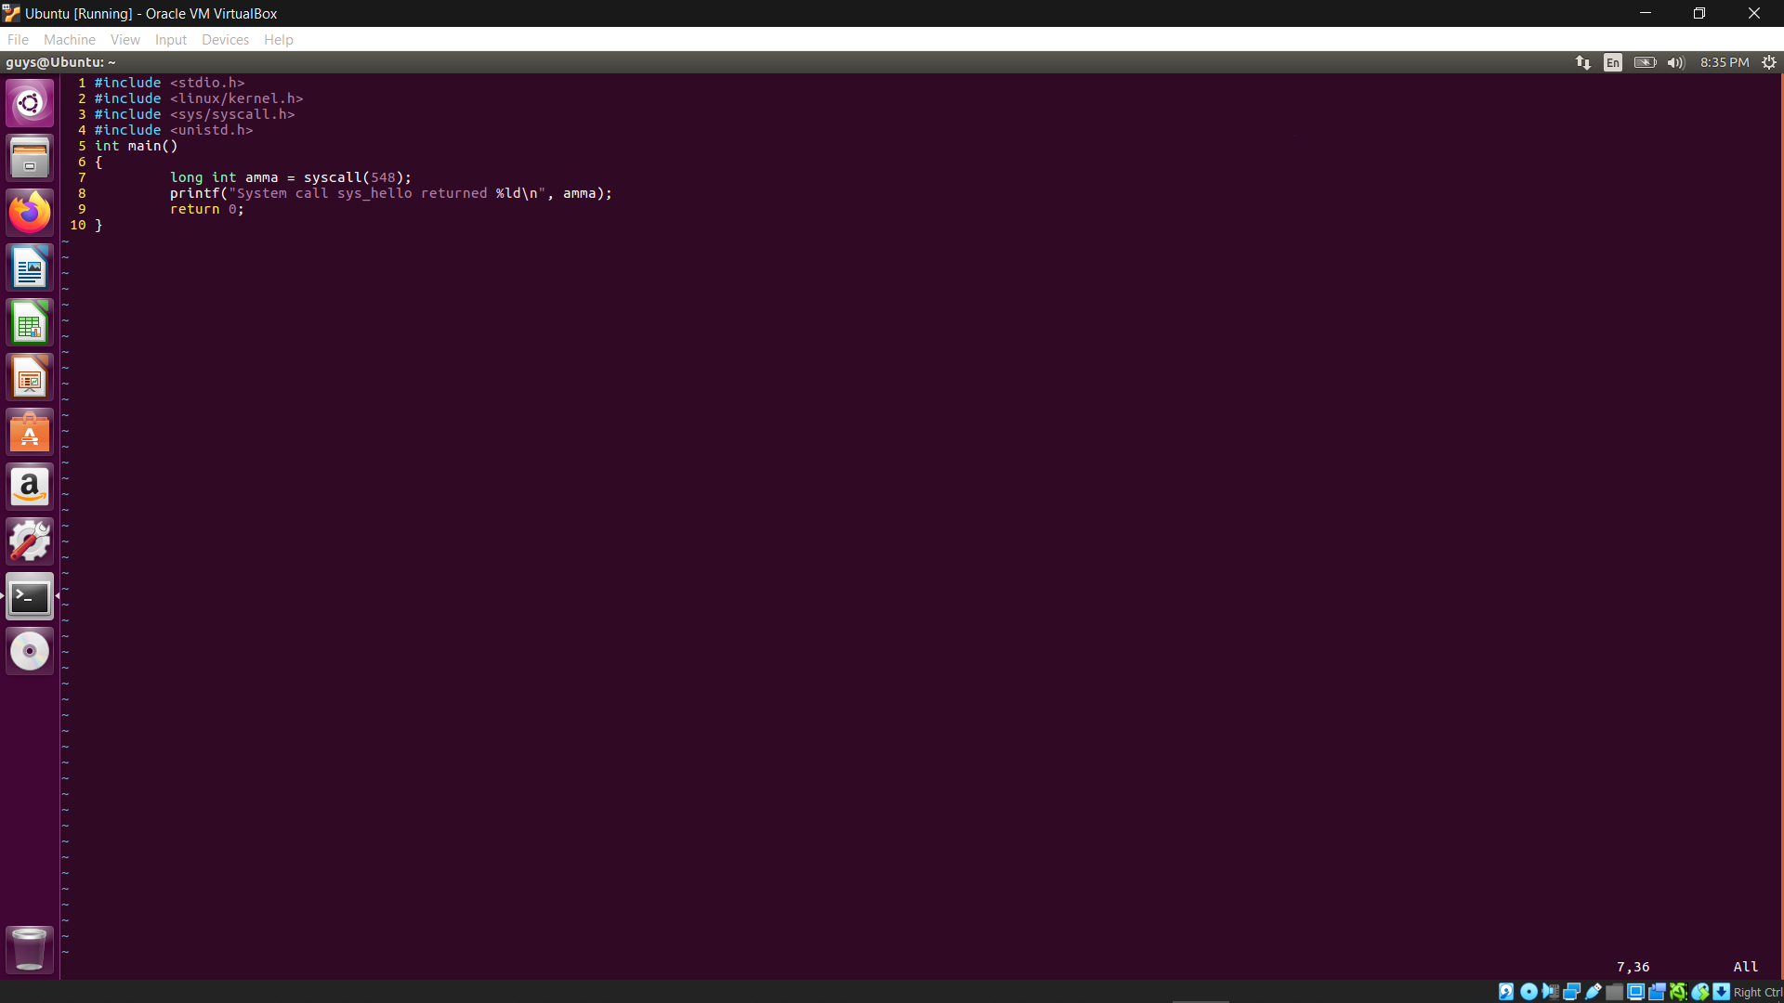

gcc test.c

./a.out

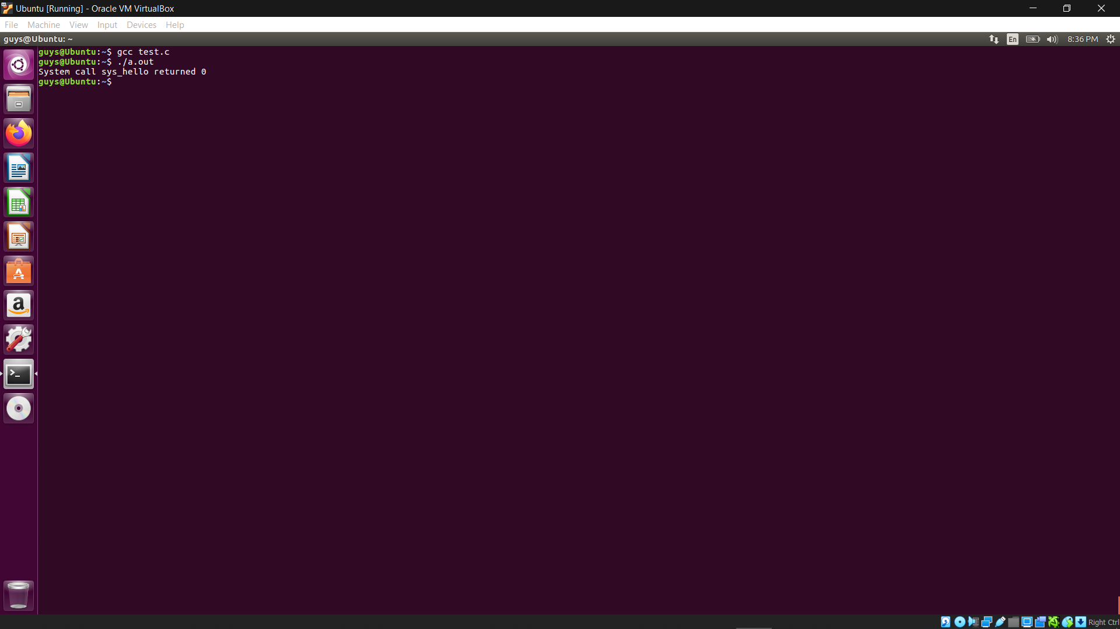

dmesg

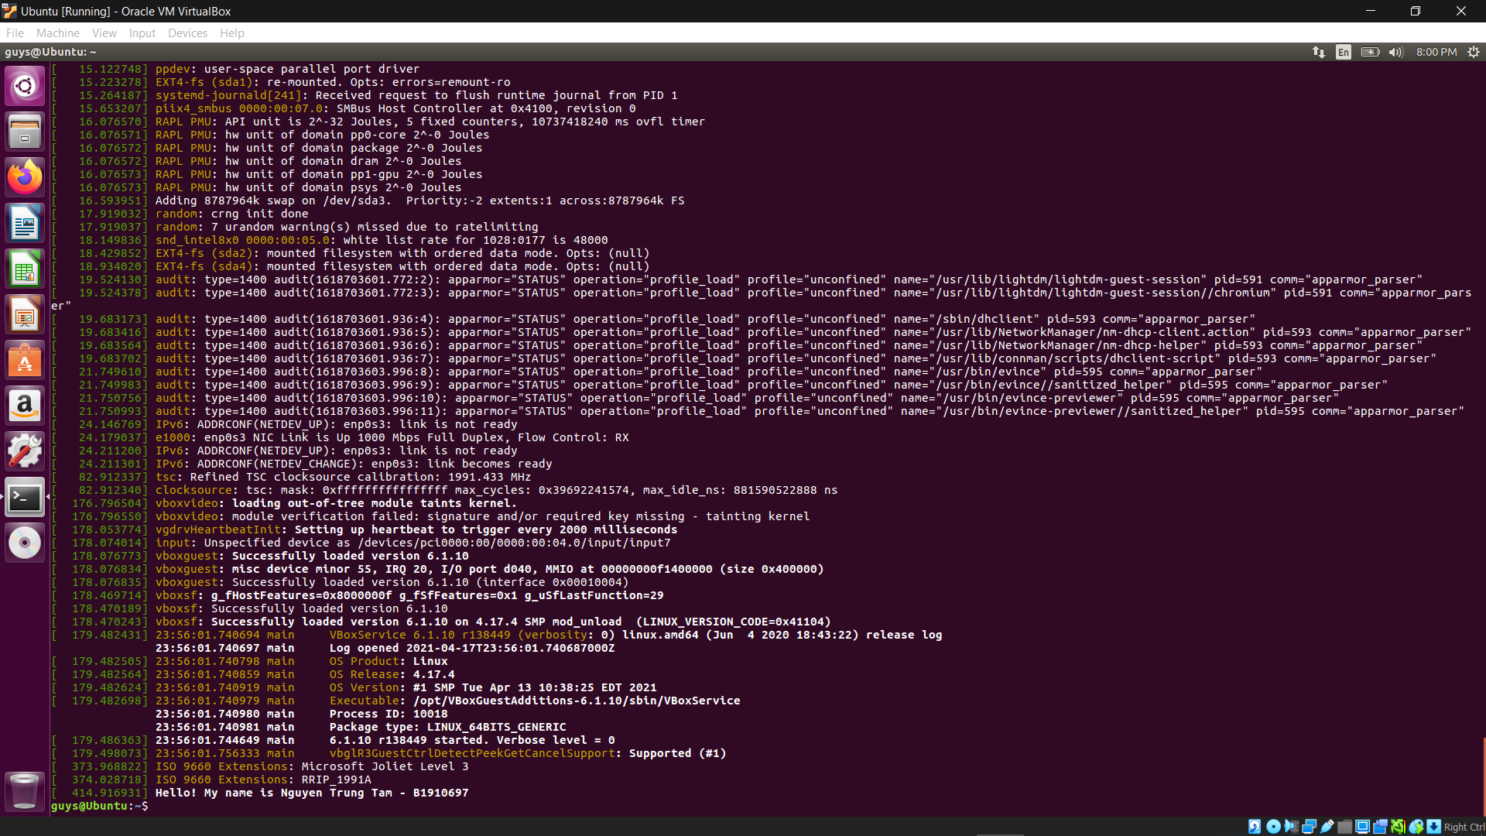

Part 3)

Part 3 is almost the same as part 2 with some difference:

wget <https://www.kernel.org/pub/linux/kernel/v4.x/linux-4.17.4.tar.xz>

tar -xvf linux-4.17.4.tar.xz -C/usr/src/



uname -r



mkdir hello

cd hello



vi print_self.c

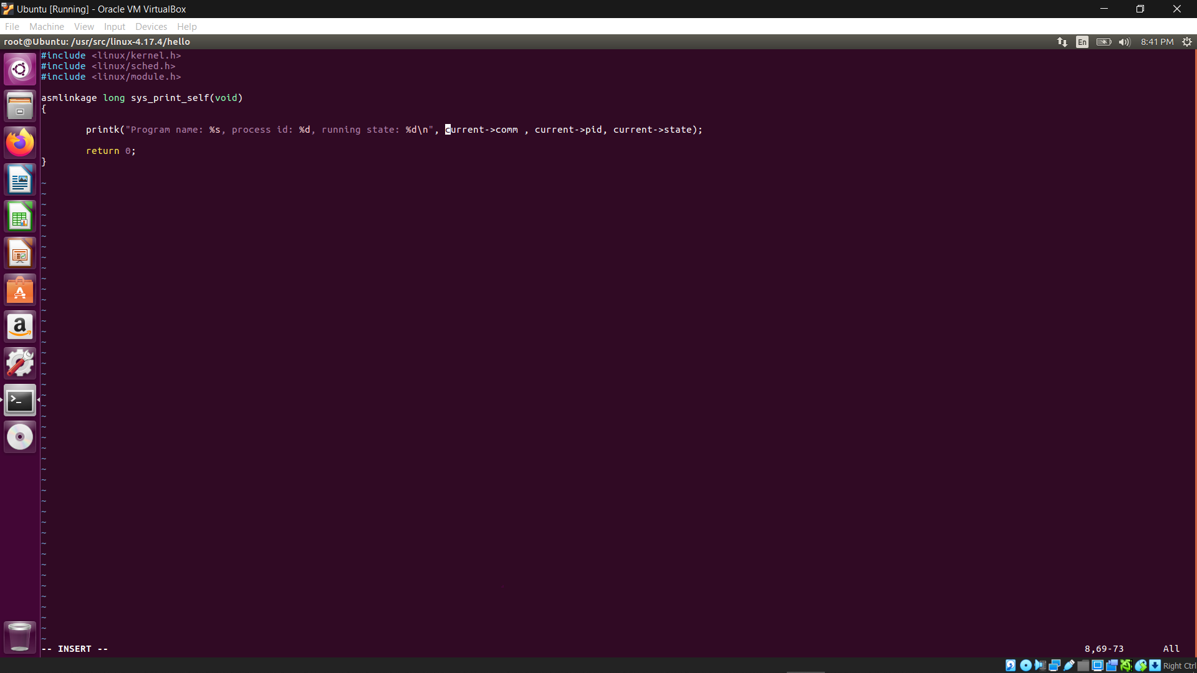

vi Makefile

obj += print_self.o

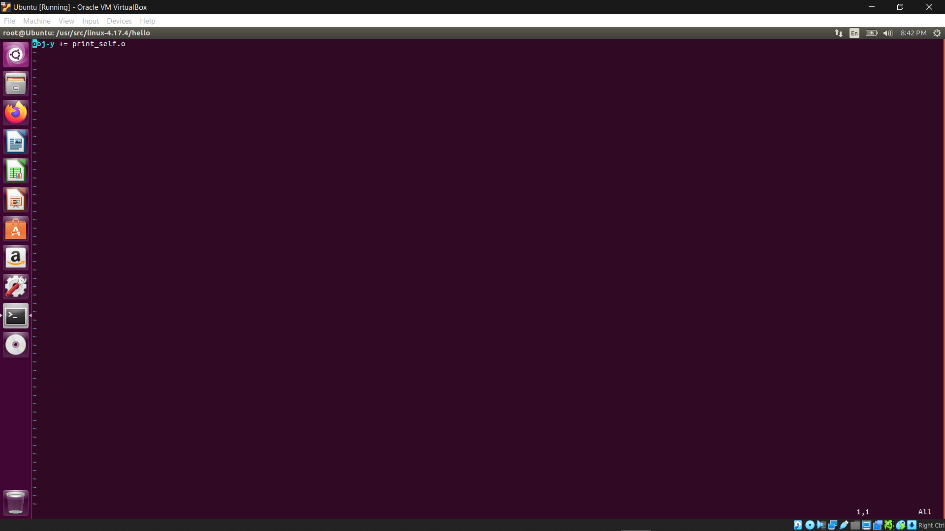

cd ..

vi Makefile

core-y += kernel/ mm/ fs/ ipc/ security/ crypto/ block/ hello/



cd arch/x86/entry/syscalls/

vi syscall_64.tbl

549 64 print_self sys_print_self

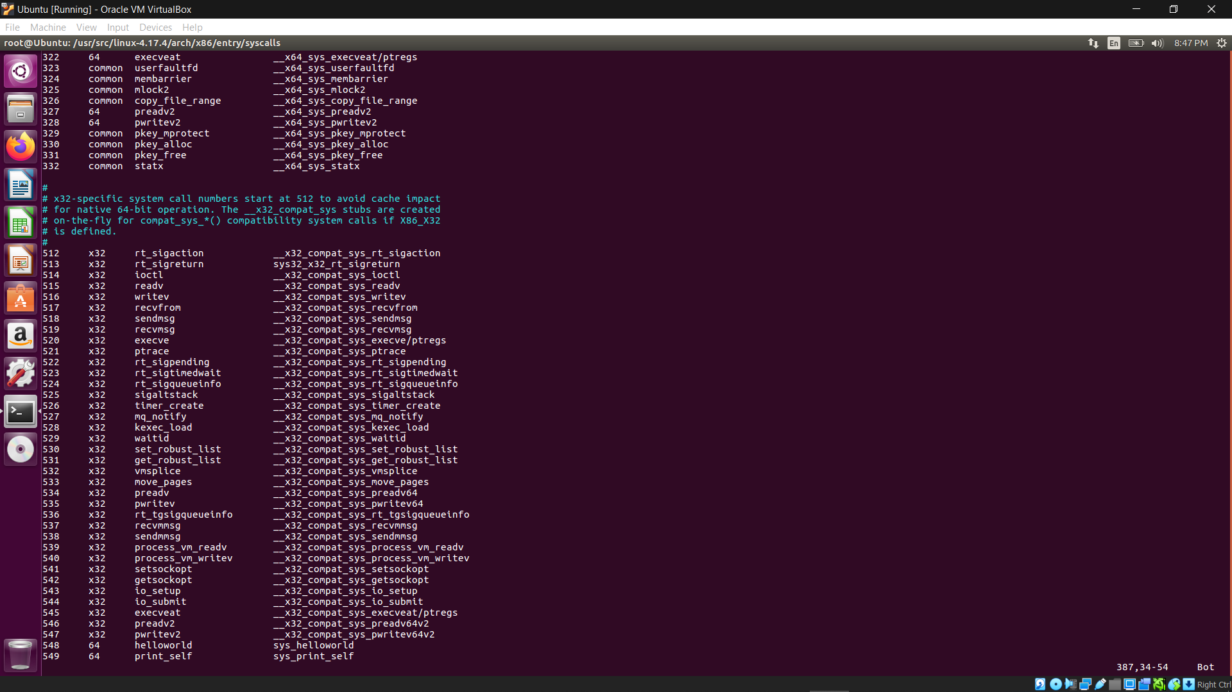

cd include/linux/

vi syscalls.h

asmlinkage long sys_print_self(void);

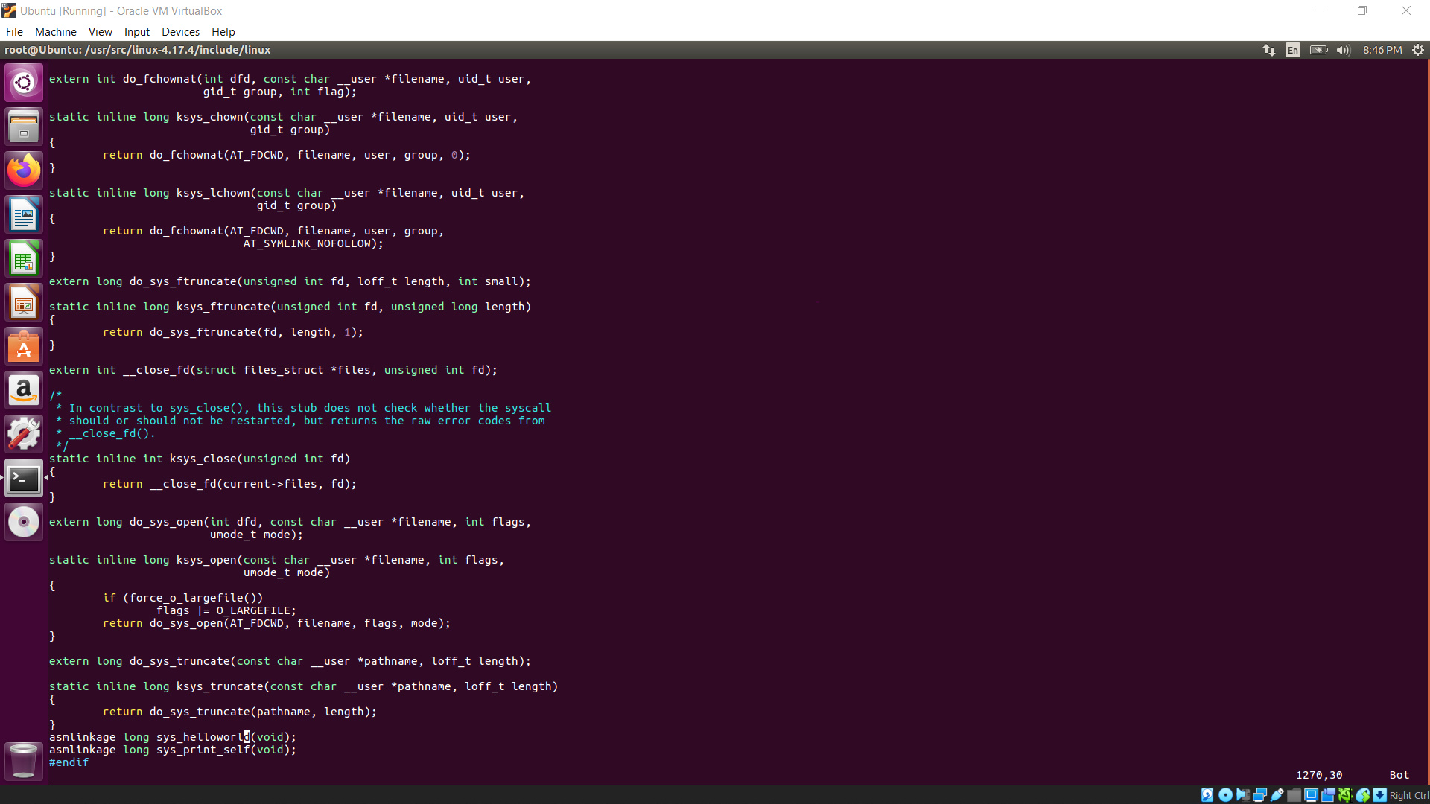

apt-get install gcc

apt-get install libncurses5-dev

apt-get install bison

apt-get install flex

apt-get install libssl-dev

apt-get install libelf-dev

apt-get update

apt-get upgrade

make menuconfig



make



make modules_install install





uname -r



cd ~

vi test.c

#include <stdio.h>

#include <linux/kernel.h>

#include <sys/syscall.h>

#include <unistd.h>

int main()

{

long int amma = syscall(549);

printf("System call sys_print_self returned %ld\n", amma);

return 0;

}

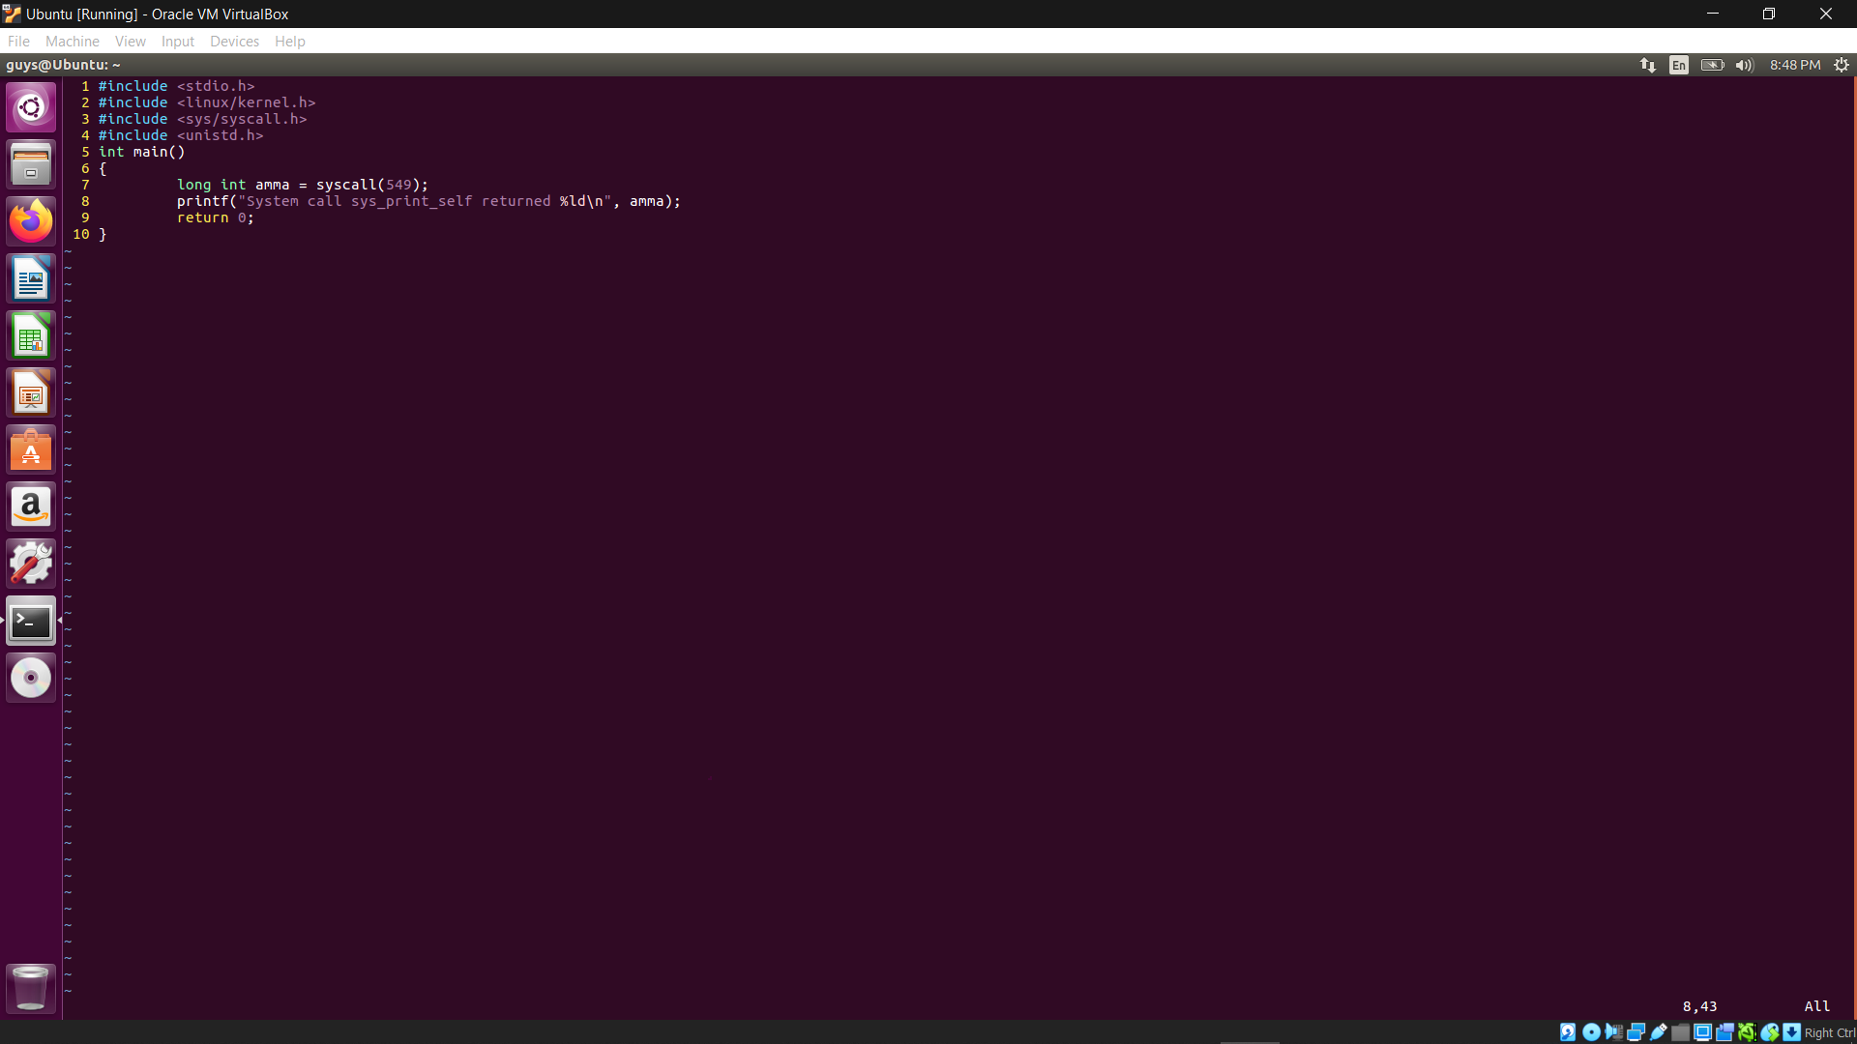

gcc test.c

./a.out



dmesg

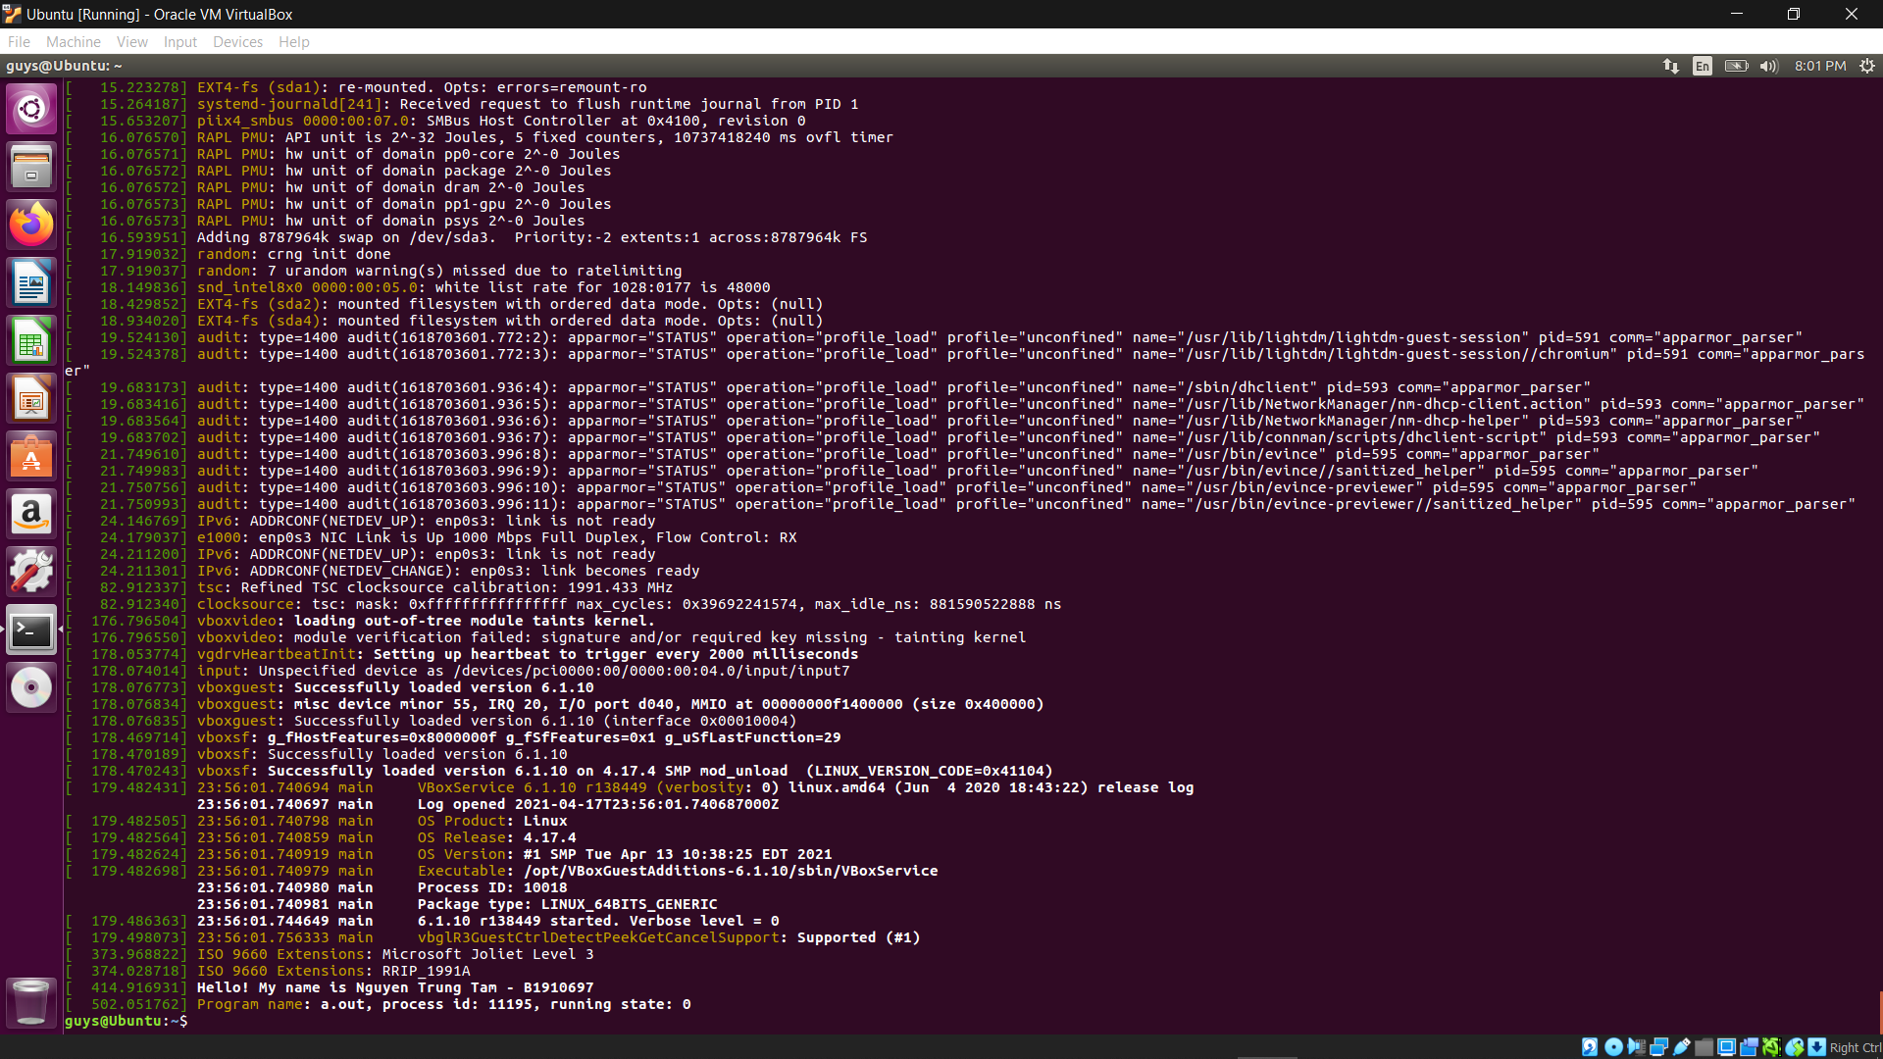

# Part 4) CPU SCHEDULING

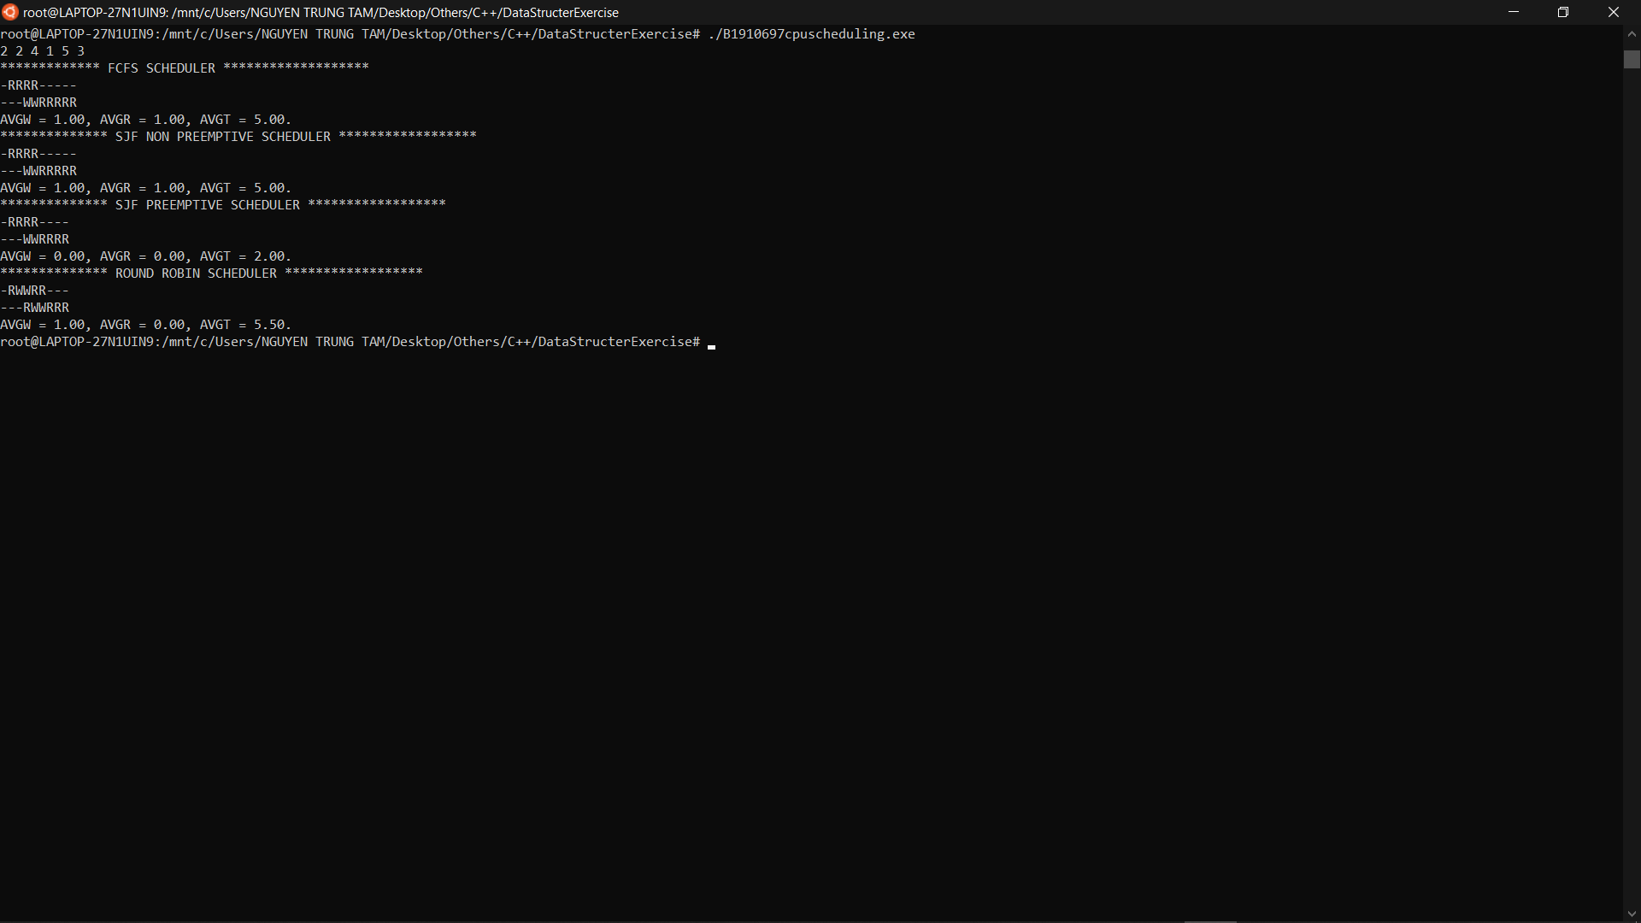

#include <stdio.h>

#include <stdlib.h>

#include <string.h>

typedef struct process {

char name[5];

int bt; // burstTime

int at; // arrivalTime

int prt; // previous time

int wt, ta; // ta = turnaround time, wt= waiting time

int rt, served; //rt= round robin time

int flag;

} processes;

typedef struct outPro {

int index;

int start;

int end;

} outPro;

void b_sort(processes temp[], int n) {

processes t;

int i, j;

for (i = 1; i < n; i++)

for (j = 0; j < n - i; j++) {

if (temp[j].at > temp[j + 1].at) {

t = temp[j];

temp[j] = temp[j + 1];

temp[j + 1] = t;

}

}

}

// FCFS Algorithm

void FCFS(processes P[], int n) {

processes temp[10];

int sumw = 0, sumt = 0; // sum time

int x = 0;

float avgwt = 0.0, avgta = 0.0; // avg time

int i, j; // count var

// copy

for (i = 0; i < n; i++)

temp[i] = P[i];

// sort by arrival time

b_sort(temp, n);

// init

sumw = temp[0].wt = 0;

sumt = temp[0].ta = temp[0].bt - temp[0].at;

// compute wating time and sum wating, sum turn around

for (i = 1; i < n; i++) {

temp[i].wt =

(temp[i - 1].bt + temp[i - 1].at + temp[i - 1].wt) - temp[i].at;

;

temp[i].ta = (temp[i].wt + temp[i].bt);

sumw += temp[i].wt;

sumt += temp[i].ta;

}

avgwt = (float)sumw / n;

avgta = (float)sumt / n;

// end time

int end = 0;

for (i = 1; i <= n; i++) {

end += temp[i - 1].bt;

}

x = 0;

int prevBt = 0;

for (i = 1; i <= n; i++) {

x += temp[i - 1].bt;

for (int k = 0; k <= end; k++) {

int at = temp[i - 1].at;

if (k < at) {

printf("-");

} else if (k <= prevBt) {

printf("W");

} else if (k <= x) {

printf("R");

} else {

printf("-");

}

}

printf("\n");

prevBt = x;

}

printf("AVGW = %0.2f, AVGR = %0.2f, AVGT = %0.2f.\n", avgwt, avgwt, avgta);

}

// SJF Non Pre-emptive

void SJF_NP(processes P[], int n) {

processes temp[10];

processes t;

int sumw = 0, sumt = 0;

int x = 0;

float avgwt = 0.0, avgta = 0.0;

int i, j;

for (i = 0; i < n; i++)

temp[i] = P[i];

b_sort(temp, n);

for (i = 2; i < n; i++)

for (j = 1; j < n - i + 1; j++) {

if (temp[j].bt > temp[j + 1].bt) {

t = temp[j];

temp[j] = temp[j + 1];

temp[j + 1] = t;

}

}

sumw = temp[0].wt = 0;

sumt = temp[0].ta = temp[0].bt - temp[0].at;

for (i = 1; i < n; i++) {

temp[i].wt =

(temp[i - 1].bt + temp[i - 1].at + temp[i - 1].wt) - temp[i].at;

;

temp[i].ta = (temp[i].wt + temp[i].bt);

sumw += temp[i].wt;

sumt += temp[i].ta;

}

avgwt = (float)sumw / n;

avgta = (float)sumt / n;

int end = 0;

for (i = 1; i <= n; i++) {

end += temp[i - 1].bt;

}

int preX = 0;

x = 0;

for (i = 1; i <= n; i++) {

x += temp[i - 1].bt;

for (int j = 0; j <= end; j++) {

if (j < temp[i - 1].at) {

printf("-");

} else if (j >= temp[i - 1].at && j <= preX) {

printf("W");

} else if (j <= x) {

printf("R");

} else {

printf("-");

}

}

preX = x;

printf("\n");

}

printf("AVGW = %0.2f, AVGR = %0.2f, AVGT = %0.2f.\n", avgwt, avgwt, avgta);

}

// Priority Non Pre-emptive

void PRT_NP(processes P[], int n) {

processes temp[10];

processes t;

int sumw = 0, sumt = 0;

float avgwt = 0.0, avgta = 0.0;

int i, j;

int x = 0;

for (i = 0; i < n; i++)

temp[i] = P[i];

b_sort(temp, n);

for (i = 2; i < n; i++)

for (j = 1; j < n - i + 1; j++) {

if (temp[j].prt > temp[j + 1].prt) {

t = temp[j];

temp[j] = temp[j + 1];

temp[j + 1] = t;

}

}

sumw = temp[0].wt = 0;

sumt = temp[0].ta = temp[0].bt - temp[0].at;

for (i = 1; i < n; i++) {

temp[i].wt =

(temp[i - 1].bt + temp[i - 1].at + temp[i - 1].wt) - temp[i].at;

;

temp[i].ta = (temp[i].wt + temp[i].bt);

sumw += temp[i].wt;

sumt += temp[i].ta;

}

avgwt = (float)sumw / n;

avgta = (float)sumt / n;

printf("\n");

int total = x;

int preX = 0;

x = 0;

for (i = 1; i <= n; i++) {

x += temp[i - 1].bt;

for (int j = 0; j <= total; j++) {

if (j < temp[i - 1].at) {

printf("-");

} else if (j >= temp[i - 1].at && j <= preX) {

printf("W");

} else if (j <= x) {

printf("R");

} else {

printf("-");

}

}

preX = x;

printf("\n");

}

printf("AVGW = %0.2f, AVGR = %0.2f, AVGT = %0.2f.\n", avgwt, avgwt, avgta);

}

// Round Robin Scheduling

void RR(processes P[], int n, int q) {

int pflag = 0, t, tcurr = 0, k, i, Q = q;

int sumw = 0, sumt = 0, sumr = 0;

float avgwt = 0.0, avgta = 0.0, avgrt = 0.0;

processes temp1[10], temp2[10];

for (i = 0; i < n; i++)

temp1[i] = P[i];

b_sort(temp1, n);

for (i = 0; i < n; i++)

temp2[i] = temp1[i];

outPro outProes[10];

for (int k = 0; k < 10; k++) {

outProes[i].index = -1;

outProes[i].start = -1;

outProes[i].end = -1;

}

int preTCurr = 0;

int preIndex = 0;

int flagFirst = 1;

int countOutProes = 0;

int endRunTime = 0;

for (k = 0;; k++) {

if (k > n - 1)

k = 0;

if (temp1[k].bt > 0) {

if (flagFirst) {

flagFirst = 0;

} else {

outProes[countOutProes].index = preIndex;

outProes[countOutProes].start = preTCurr;

outProes[countOutProes].end = tcurr;

countOutProes++;

preTCurr = tcurr;

preIndex = k;

}

}

t = 0;

while (t < Q && temp1[k].bt > 0) {

t++;

tcurr++;

temp1[k].bt--;

}

if (tcurr < temp1[k].at) {

tcurr += temp1[k].at;

}

if (temp1[k].bt <= 0 && temp1[k].flag != 1) {

temp1[k].wt = tcurr - temp2[k].bt - temp1[k].at;

temp1[k].ta = tcurr - temp1[k].at;

pflag++;

temp1[k].flag = 1;

sumw += temp1[k].wt;

sumt += temp1[k].ta;

// Response time

if (!temp1[i].served) {

temp1[i].rt = (tcurr + 1) - temp1[i].bt - temp1[i].at;

temp1[i].served = 1;

sumr += (tcurr + 1) - temp1[i].bt - temp1[i].at;

}

}

if (pflag == n) {

endRunTime = tcurr;

break;

}

}

outProes[countOutProes].index = k;

outProes[countOutProes].start = preTCurr;

outProes[countOutProes].end = tcurr;

int proIndex = 0;

int preEnd = 0;

for (int k = 0; k < n; k++) {

for (int l = 0; l <= countOutProes; l++) {

if (proIndex == outProes[l].index) {

int at = temp1[outProes[l].index].at;

for (int t = preEnd; t < outProes[l].end; t++) {

if (t < at) {

printf("-");

} else if (t >= at && t < outProes[l].start) {

printf("W");

} else if (t >= outProes[l].start && t <= outProes[l].end) {

printf("R");

} else if (preEnd > at) {

printf("W");

} else {

printf("-");

}

}

preEnd = outProes[l].end;

}

}

int t_total = 0;

for (int z = 0; z < endRunTime - preEnd; z++) {

printf("-");

}

printf("\n");

preEnd = 0;

proIndex++;

}

avgwt = (float)sumw / n;

avgta = (float)sumt / n;

avgrt = (float)sumr / n;

printf("AVGW = %0.2f, AVGR = %0.2f, AVGT = %0.2f.\n", avgwt, avgrt, avgta);

}

// Shortest Job First - Pre-emptive

void SJF_P(processes P[], int n) {

int i, t_total = 0, tcurr, b[10], min_at, j, x, min_bt;

int sumw = 0, sumt = 0, sumr = 0;

float avgwt = 0.0, avgta = 0.0, avgrt = 0.0;

processes temp[10], t;

for (i = 0; i < n; i++) {

temp[i] = P[i];

t_total += P[i].bt;

}

b_sort(temp, n);

for (i = 0; i < n; i++)

b[i] = temp[i].bt;

i = j = 0;

outPro outProes[10];

for (int k = 0; k < 10; k++) {

outProes[i].index = -1;

outProes[i].start = -1;

outProes[i].end = -1;

}

int preTCurr = 0;

int preIndex = 0;

int flagFirst = 1;

int countOutProes = 0;

outProes[countOutProes].index = 0;

outProes[countOutProes].start = preTCurr;

countOutProes++;

for (tcurr = 0; tcurr < t_total; tcurr++) {

if (b[i] > 0 && temp[i].at <= tcurr)

b[i]--;

// Me

if (i != j) {

if (flagFirst) {

outProes[0].end = tcurr;

flagFirst = 0;

} else {

outProes[countOutProes].index = preIndex;

outProes[countOutProes].start = preTCurr;

outProes[countOutProes].end = tcurr;

countOutProes++;

}

preTCurr = tcurr;

preIndex = i;

}

if (b[i] <= 0 && temp[i].flag != 1) {

temp[i].flag = 1;

temp[i].wt = (tcurr + 1) - temp[i].bt - temp[i].at;

temp[i].ta = (tcurr + 1) - temp[i].at;

sumw += temp[i].wt;

sumt += temp[i].ta;

// Response time

if (!temp[i].served) {

temp[i].rt = (tcurr + 1) - temp[i].bt - temp[i].at;

temp[i].served = 1;

sumr += (tcurr + 1) - temp[i].bt - temp[i].at;

}

}

j = i;

min_bt = 999;

for (x = 0; x < n; x++) {

if (temp[x].at <= (tcurr + 1) && temp[x].flag != 1) {

if (min_bt != b[x] && min_bt > b[x]) {

min_bt = b[x];

i = x;

}

}

}

}

outProes[countOutProes].index = i;

outProes[countOutProes].start = preTCurr;

outProes[countOutProes].end = tcurr;

int proIndex = 0;

int preEnd = 0;

for (int k = 0; k < n; k++) {

for (int l = 0; l <= countOutProes; l++) {

if (proIndex == outProes[l].index) {

int at = temp[outProes[l].index].at;

for (int t = preEnd; t < outProes[l].end; t++) {

if (t < at) {

printf("-");

} else if (t >= at && t < outProes[l].start) {

printf("W");

} else if (t >= outProes[l].start && t <= outProes[l].end) {

printf("R");

} else if (preEnd > at) {

printf("W");

} else {

printf("-");

}

}

preEnd = outProes[l].end;

}

}

for (int z = 0; z < t_total - preEnd; z++) {

printf("-");

}

printf("\n");

preEnd = 0;

proIndex++;

}

avgwt = (float)sumw / n;

avgta = (float)sumt / n;

avgrt = (float)sumr / n;

printf("AVGW = %0.2f, AVGR = %0.2f, AVGT = %0.2f.\n", avgwt, avgrt, avgta);

}

void PRT_P(processes P[], int n) {

int i, t_total = 0, tcurr, b[10], j, x, min_pr;

int sumw = 0, sumt = 0, sumr = 0;

float avgwt = 0.0, avgta = 0.0, avgrt = 0.0;

processes temp[10], t;

for (i = 0; i < n; i++) {

temp[i] = P[i];

t_total += P[i].bt;

}

b_sort(temp, n);

for (i = 0; i < n; i++)

b[i] = temp[i].bt;

i = j = 0;

outPro outProes[10];

for (int k = 0; k < 10; k++) {

outProes[i].index = -1;

outProes[i].start = -1;

outProes[i].end = -1;

}

int preTCurr = 0;

int preIndex = 0;

int flagFirst = 1;

int countOutProes = 0;

outProes[countOutProes].index = 0;

outProes[countOutProes].start = preTCurr;

countOutProes++;

// printf("\n GANTT CHART\n\n %d %s", i, temp[i].name);

for (tcurr = 0; tcurr < t_total; tcurr++) {

if (b[i] > 0 && temp[i].at <= tcurr)

b[i]--;

if (i != j) {

if (flagFirst) {

outProes[0].end = tcurr;

flagFirst = 0;

} else {

outProes[countOutProes].index = preIndex;

outProes[countOutProes].start = preTCurr;

outProes[countOutProes].end = tcurr;

countOutProes++;

}

preTCurr = tcurr;

preIndex = i;

}

// if (i != j)

// printf(" %d %s", tcurr, temp[i].name);

if (b[i] <= 0 && temp[i].flag != 1) {

temp[i].flag = 1;

temp[i].wt = (tcurr + 1) - temp[i].bt - temp[i].at;

temp[i].ta = (tcurr + 1) - temp[i].at;

sumw += temp[i].wt;

sumt += temp[i].ta;

}

j = i;

min_pr = 999;

for (x = 0; x < n; x++) {

if (temp[x].at <= (tcurr + 1) && temp[x].flag != 1) {

if (min_pr != temp[x].prt && min_pr > temp[x].prt) {

min_pr = temp[x].prt;

i = x;

}

}

}

}

printf(" %d", tcurr);

outProes[countOutProes].index = i;

outProes[countOutProes].start = preTCurr;

outProes[countOutProes].end = tcurr;

printf("\n");

for (int k = 0; k <= countOutProes; k++) {

printf("Index: %d, Start: %d, End %d\n", outProes[k].index,

outProes[k].start, outProes[k].end);

}

int proIndex = 0;

int preEnd = 0;

for (int k = 0; k < n; k++) {

printf("Process: %d ", proIndex);

for (int l = 0; l <= countOutProes; l++) {

if (proIndex == outProes[l].index) {

int at = temp[outProes[l].index].at;

for (int t = preEnd; t < outProes[l].end; t++) {

if (t < at) {

printf("-");

} else if (t >= at && t < outProes[l].start) {

printf("W");

} else if (t >= outProes[l].start && t <= outProes[l].end) {

printf("R");

} else if (preEnd > at) {

printf("W");

} else {

printf("-");

}

}

preEnd = outProes[l].end;

}

}

for (int z = 0; z < t_total - preEnd; z++) {

printf("-");

}

printf("\n");

preEnd = 0;

proIndex++;

}

avgwt = (float)sumw / n;

avgta = (float)sumt / n;

printf("AVGW = %0.2f, AVGR = %0.2f, AVGT = %0.2f.\n", avgwt, avgrt, avgta);

}

int readInput(processes P[], int *q) {

int i, n;

scanf("%d", &n);

scanf("%d", q);

char buf[3];

for (i = 0; i < n; i++) {

snprintf(buf, 3, "P%d", i);

strncpy(P[i].name, buf, 5);

scanf("%d", &P[i].bt);

scanf("%d", &P[i].at);

}

return n;

}

int main() {

processes P[10];

int ch, n, q;

n = readInput(P, &q);

printf("************* FCFS SCHEDULER *******************\n");

FCFS(P, n);

printf("************** SJF NON PREEMPTIVE SCHEDULER ******************\n");

SJF_NP(P, n);

printf("************** SJF PREEMPTIVE SCHEDULER ******************\n");

SJF_P(P, n);

printf("************** ROUND ROBIN SCHEDULER ******************\n");

RR(P, n, q);

return 0;

}

# Part 5) MEMORY MANAGEMENT

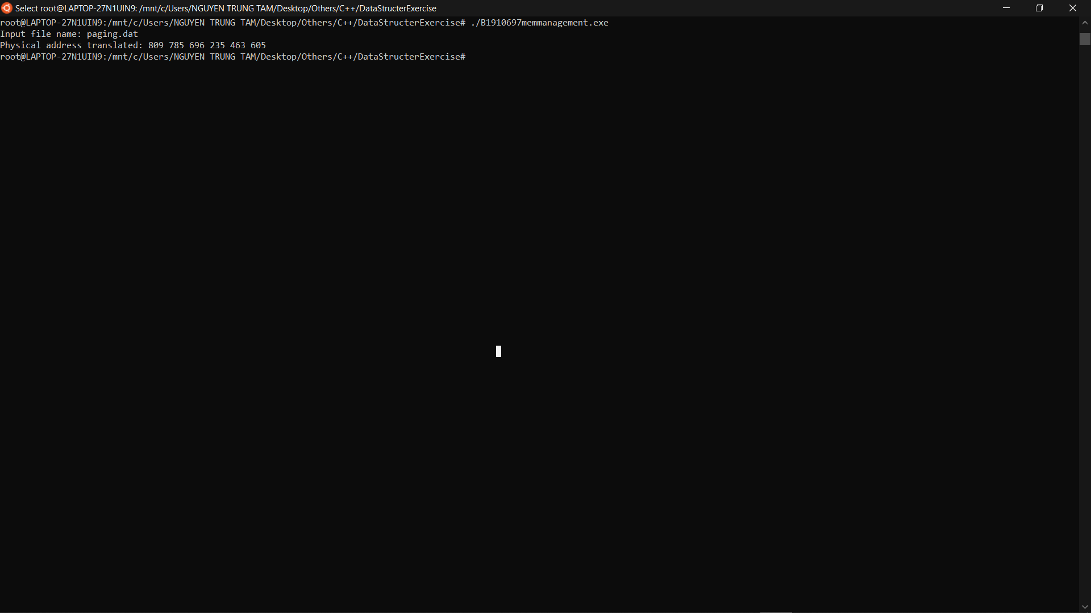

#include <stdio.h>

#include <stdlib.h>

#include <string.h>

#define N 6

#define SPACE 1024

#define PAGE_SIZE 128

// convert from logic to physic address

unsigned long convert(int pageSize, int map[], unsigned long n) {

unsigned long x = n / pageSize;

unsigned long r = n % pageSize;

if (x >= SPACE / pageSize)

return 0;

return map[x] * pageSize + r;

}

// read logical address

unsigned long *readFile(char *filename) {

FILE *fp;

fp = fopen(filename, "rb");

unsigned long *ret;

ret = malloc(N * sizeof(unsigned long));

int count = 0;

while (!feof(fp)) {

fread(ret + count, sizeof(unsigned long), 1, fp);

count++;

}

fclose(fp);

return ret;

}

int main() {

int n;

// Page size

int pageSize = PAGE_SIZE;

// page table

int map[] = {6, 5, 4, 2, 7, 3, 1};

// file name

char filename[100];

printf("Input file name: ");

fgets(filename, 100, stdin);

filename[strlen(filename) - 1] = 0;

printf("Physical address translated: ");

for (size_t i = 0; i < N; i++) {

unsigned long *ret = readFile(filename);

printf("%lu ", convert(pageSize, map, *(ret + i)));

}

printf("\n");

return 0;

}

# Part 6)

#### Question 6.1: What is the virtual machine

A virtual machine (VM) is a virtual environment that functions as a virtual computer system with its own CPU, memory, network interface, and storage, created on a physical hardware system (located off- or on-premises). Software called a hypervisor separates the machine’s resources from the hardware and provisions them appropriately so they can be used by the VM.

The physical machines, equipped with a hypervisor such as Kernel-based Virtual Machine (KVM), is called the host machine, host computer, host operating system, or simply host. The many VMs that use its resources are guest machines, guest computers, guest operating systems, or simply guests. The hypervisor treats compute resources—like CPU, memory, and storage—as a pool of resources that can easily be relocated between existing guests or to new virtual machines.

VMs are isolated from the rest of the system, and multiple VMs can exist on a single piece of hardware, like a server. They can be moved between host servers depending on demand or to use resources more efficiently.

VMs allow multiple different operating systems to run simultaneously on a single computer—like a Linux® distro on a MacOS laptop. Each operating system runs in the same way an operating system or application normally would on the host hardware, so the end user experience emulated within the VM is nearly identical to a real-time operating system experience running on a physical machine.

#### Question 6.2: What are the advantages and disadvantages of VM?

Advantages:

* Can use multiple operating system environments on the same computer.
* Virtual machines can provide an instruction set architecture, or ISA, structure different than the actual computer. The ISA serves as the interface between software and hardware.
* When you create your virtual machine, you create a virtual hard disk. So, everything on that machine can crash, but if it does, it won’t affect the host machine.
* There are security benefits to running virtual machines. For example, if you need to run an application of questionable security, you can run it in a guest operating system. So, if the application causes damage, then it will be only temporary after the guest is shut down. Virtual machines also allow for better security forensics by monitoring guest operating systems for deficiencies and allowing the user to quarantine it for analysis.

Disadvantages:

* Virtual machines are less efficient than real machines because they access the hardware indirectly. Running software on top of the host operating system means that it will have to request access to the hardware from the host. That will slow the usability.
* When several virtual machines are running on the same host, performance may be hindered if the computer it’s running on lacks sufficient power. Your virtual machine still uses the resources of your host machine. The more powerful the host computer, the more quickly the virtual machine will run.
* A virtual machine can be infected with the weaknesses of the host machine. As an example, process isolation is a feature usually employed by operating systems. However, there are bugs that violate it. A regular computer devoid of virtual machines would then only be affected. But, a computer with a number of virtual machines would then infect each of those “machines” as well.

#### Question 6.3: What are types of virtual machine and their implementation?

1. System Virtual Machine:

These types of virtual machines gives us complete system platform and gives the execution of the complete virtual operating system. Just like virtual box, system virtual machine is providing an environment for an OS to be installed completely. We can see in below image that our hardware of Real Machine is being distributed between two simulated operating systems by Virtual machine monitor. And then some programs, processes are going on in that distributed hardware of simulated machines separately.

2. Process Virtual Machine :

While process virtual machines, unlike system virtual machine, does not provide us with the facility to install the virtual operating system completely. Rather it creates virtual environment of that OS while using some app or program and this environment will be destroyed as soon as we exit from that app. Like in below image, there are some apps running on main OS as well some virtual machines are created to run other apps. This shows that as those programs required different OS, process virtual machine provided them with that for the time being those programs are running.

1. Virtual Machine Language :

It’s type of language which can be understood by different operating systems. It is platform-independent. Just like to run any programming language (C, python, or java) we need specific compiler that actually converts that code into system understandable code (also known as byte code). The same virtual machine language works. If we want to use code that can be executed on different types of operating systems like (Windows, Linux, etc) then virtual machine language will be helpful.

# Part 7)

#### Question 7.1: What is the output of the following program? Why?

Output:

Hello world!

Hello world!

Hello world!

Hello world!

Hello world!

Hello world!

Hello world!

Hello world!

Because in main function the parent process (the process of the program) create 1 process using fork() so there will be 2 processes, after it call fork() again, then 2 process created will call fork(), make 2 new processes, so there will be 4 processes, and then it call fork() again, then 4 processes will create by 4 processes created before, so there will be 8 processes, and then it will print 8 “Hello world” in screen.

#### Question 7.2: What is the output of the following program? Why ?

Hello from pid (parent pid)

Hello from pid (child pid)

Or error when create child process not success.

#### Question 7.3:

The output:

Parent has x = 0

Child has x = 2

(or)

Child has x = 2

Parent has x = 0

In program, the global variable change in one process does not affected two other processes because data/state of two processes are different. And also parent and child run simultaneously so two outputs are possible.

#### Question 7.5:

Program 1:

The output will be:

6

1537

Because in parent process after create child process it will wait for child to finish (increase val to 6 and print val so 6 is print on screen), then the exit code (in this case is val, with value 6, but consist of the least significant 8 bits of the status that the child specified in call exit() so 6 * ( 2 ^ 8) = 1536) is return to val (val now has value 1536), then the parent continue execute the program (increase val to 1537 and print val (1537) on screen).

Program 2:

The output will be:

1281

Because in parent process after create child process it will wait for child to finish, but in child process it will exit immediately with status code 5 ( but consist of the least significant 8 bits of the status that the child specified in call exit() so 5 * ( 2 ^ 8) = 1280) to parent process and not execute anything else (not print val on screen), then parent process continue execute (increase val to 1281 and print val so 1281 is print on screen).

#### Question 7.7

Zombie process:

A process which has finished the execution but still has entry in the process table to report to its parent process is known as a zombie process.

Code demonstrate:

// A C program to demonstrate Zombie Process.

// Child becomes Zombie as parent is sleeping

// when child process exits.

#include <stdlib.h>

#include <sys/types.h>

#include <unistd.h>

int main()

{

// Fork returns process id

// in parent process

pid_t child_pid = fork();

// Parent process

if (child_pid > 0)

sleep(50);

// Child process

else

exit(0);

return 0;

}

The child finish execution using exit(), but the parent sleep for 50 secs, so the child process’s entry still exists in the process table.

Orphan process:

A process whose parent process no more exists i.e. either finished or terminated without waiting for its child process to terminate is called an orphan process.

Code demonstrate:

/ A C program to demonstrate Orphan Process.

// Parent process finishes execution while the

// child process is running. The child process

// becomes orphan.

#include<stdio.h>

#include <sys/types.h>

#include <unistd.h>

int main()

{

// Create a child process

int pid = fork();

if (pid > 0)

printf("in parent process");

// Note that pid is 0 in child process

// and negative if fork() fails

else if (pid == 0)

{

sleep(30);

printf("in child process");

}

return 0;

}

### References:

https://www.geeksforgeeks.org/types-of-virtual-machines/

<https://www.cynexlink.com/2017/08/18/virtual-machines-pros-cons/>

<https://www.redhat.com/en/topics/virtualization/what-is-a-virtual-machine>

<https://medium.com/anubhav-shrimal/adding-a-hello-world-system-call-to-linux-kernel-dad32875872>

https://www.geeksforgeeks.org/zombie-and-orphan-processes-in-c/